How to install UCanAcess into Eclipse and NetBeans

[UCanAccess](http://ucanaccess.sourceforge.net/site.html) is a pure Java JDBC driver that allows us to read from and write to Access databases without using ODBC. It uses two other packages, [Jackcess](http://jackcess.sourceforge.net/) and [HSQLDB](http://hsqldb.org/), to perform these tasks. The following is a brief overview of how to get it set up.

Add the JARs to your project

As mentioned above, UCanAccess requires Jackcess and HSQLDB. Jackcess in turn has its own [dependencies](http://jackcess.sourceforge.net/dependencies.html). So to use UCanAccess you will need to include the following components:

[UCanAccess](http://ucanaccess.sourceforge.net/site.html) (ucanaccess-2.x.x.jar)  
[HSQLDB](http://hsqldb.org/) (hsqldb.jar, version 2.2.5 or newer)  
[Jackcess](http://jackcess.sourceforge.net/) (jackcess-2.x.x.jar)  
[commons-lang](http://commons.apache.org/proper/commons-lang/) (commons-lang-2.4.jar, or newer)  
[commons-logging](http://commons.apache.org/proper/commons-logging/) (commons-logging-1.0.4.jar, or newer)

Fortunately, UCanAccess includes all of the required JAR files in its distribution file. When you unzip it you will see something like

ucanaccess-2.0.4.jar

lib/commons-lang-2.6.jar

lib/commons-logging-1.1.3.jar

lib/hsqldb.jar

lib/jackcess-2.0.3.jar

All you need to do is add all five (5) JARs to your project.

**Eclipse:** Right-click the project in Package Explorer and choose Build Path > Configure Build Path.... Click “Libraries” tab on the top, Click “Modulepath” in the middle box, and the "Add External JARs..." button on the right to add each of the five (5) JARs. When you are finished your Java Build Path should look something like this

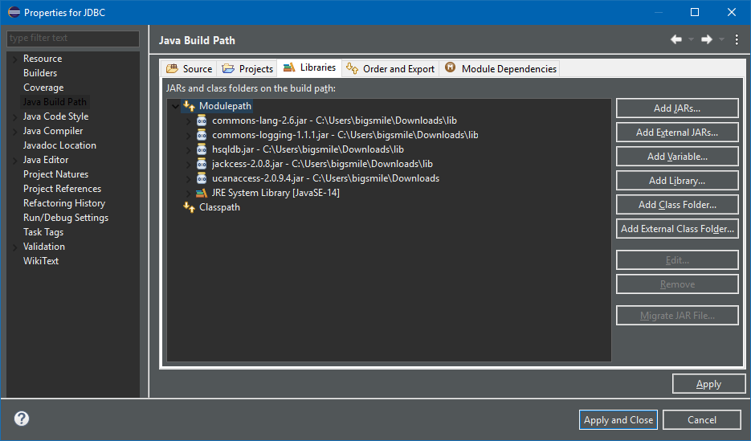

**NetBeans:** Expand the tree view for your project, right-click the "Libraries" folder and choose "Add JAR/Folder...", then browse to the JAR file.

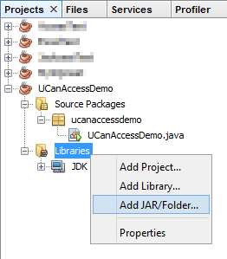

After adding all five (5) JAR files the "Libraries" folder should look something like this:

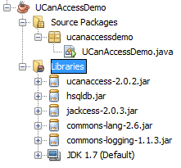

## You're set!

Now "U Can Access" data in .accdb and .mdb files using code like this

// assumes...

// import java.sql.*;

Connection conn=DriverManager.getConnection(

"jdbc:ucanaccess://C:/__tmp/test/zzz.accdb");